Module 3 - Develop a security and compliance plan

Secure your identities by using Azure Active Directory

Azure Active Directory (Azure AD) is a cloud-based identity and access management solution. It helps you secure internal, external, and customer identities.

What is Azure AD?
Azure AD is a cloud-based identity management solution. It helps your company's internal users to:
- Access external resources, like Azure services, Microsoft 365, and third-party SaaS applications.
- Access internal resources such as applications on your corporate network, and cloud-based applications that your company builds.
Azure AD also helps you keep user identities and applications secure through features like Conditional Access and identity protection.

Who benefits from Azure AD?
Azure AD meets the needs of many types of users. For instance, an IT administrator can use Azure AD to determine who should have access to applications and resources, based on company requirements. An administrator can add another layer of protection to applications and services by enforcing multi-factor authentication on sign-ins.
Application developers can use Azure AD to enable users to use preexisting credentials to access applications. Developers also use Azure AD to create personalized end-user experiences by accessing organizational user data through APIs that are specific to Azure AD.
If you subscribe to services like Azure or Microsoft 365, you're already taking advantage of Azure AD. You could use Azure AD to further manage access to your cloud applications.

Identity secure score in Azure AD
If you're an administrator, you need to know how secure your Azure AD tenant is. The identity secure score can help you understand. Azure AD gives an overall value between 1 and 223. This value represents how well you match the recommendations and best practices that Microsoft suggests for tenant security.

How Azure AD compares with Active Directory
Service | Authentication | Structure | What it's used for
Active Directory | Kerberos, NTLM | Forests, domains, organizational units | Authentication and authorization for on-premises printers, applications, file services, and more
Azure Active Directory | Includes SAML, OAuth, WS-Federation | Tenants | Internet-based services and applications like Microsoft 365, Azure services, and third-party SaaS applications

Hybrid identity for linking on-premises Active Directory with Azure AD
Your users will want to access applications from both the cloud and on-premises. You can use Azure AD and Active Directory together to provide an identity solution that spans on-premises and the cloud. A single user identity can be used for authentication and to access applications and resources, whatever their location. This user identity is called a hybrid identity.
Multiple authentication methods let you achieve hybrid identity for users:
- Azure AD password hash synchronization. Here, the user's password is hashed twice and synchronized between the on-premises Active Directory and Azure AD. Users have the same credentials to access resources and applications both on-premises and in the cloud.
- Azure AD pass-through authentication. Here, an agent is installed on on-premises servers that authenticate against the on-premises Active Directory. When an Azure AD user account tries to authenticate, password authentication is handled on-premises through these servers and Active Directory.
- Federated authentication. Here, the authentication process is performed by an on-premises Active Directory Federation Services (AD FS) server that validates users' passwords. Use this authentication method if you want advanced measures like smart card-based authentication for users.
You want to: | Password hash synchronization | Pass-through authentication | Federated authentication
Automatically synchronize to the cloud the users, contacts, and groups that have been set up on on-premises Active Directory. | Yes | Yes | Yes
Allow users to access cloud applications and resources by using their on-premises password. | Yes | Yes | Yes
Ensure that password hashes aren't stored in the cloud. | No | Yes | Yes
Use cloud-based multi-factor authentication. | Yes | Yes | Yes
Use on-premises multi-factor authentication. | No | No | Yes
Use smart card authentication for additional protection.

- Azure Active Directory Free. You can manage users and groups, and you get necessary reports, on-premises Active Directory synchronization, and self-service password reset for Azure AD users. You also get single sign-on for Microsoft 365, Azure services, and many third-party SaaS applications.
- Pay-as-you-go licenses for specific features. You access specific Azure AD features, like Azure AD B2C, on a pay-as-you-go basis. Azure AD B2C lets you manage identity and access for consumer users and the applications they use.
- Office 365 Apps. You get all of the free tier features, but you can also have custom login and logout pages, self-service password reset for cloud users and device write-back.
- Azure Active Directory Premium P1. You get all the features from the free tier, but you can also let users access on-premises and cloud-based services and resources. You can use self-service group management or dynamic groups, where users are added and removed automatically, based on your criteria. This tier supports on-premises identity management suites like Microsoft Identity Manager. Self-service password reset is also supported for users who are based on-premises.
- Azure Active Directory Premium P2. You get all the features of the previous two tiers, along with Active Directory Identity Protection. This feature helps you configure risk-based Conditional Access to protect applications from identity risks. You can also use privileged identity management, which lets you monitor and put detailed restrictions on administrators.

Default user permissions
Azure AD gives all of the users in your tenant a default set of permissions. Permissions dictate what a user can and can't do. The set of permissions granted by default depends on whether a user is a natural member of the tenant (as an internal employee) or a member of an outside organization.

Comparison of member and guest default permissions

Comparison of member and guest default permissions
Here are some of the default permissions for member users and guest users:
COMPARISON OF MEMBER AND GUEST DEFAULT PERMISSIONS
Area | Member user permissions | Guest-user permissions
Users and contacts | Can view all profile details. Can change own password, mobile phone number, and profile photos. | Can view only profile name, email, sign-in name, photo, user principal name, and user type properties of other users and contacts. Can change own password.
Devices | Can read all properties of devices. Can manage all properties of owned devices. | Can't read all properties of devices. Can't manage all properties of owned devices. Can delete owned devices.
Applications | Can register new applications. | Can't register new applications. Can delete owned applications.
Policies | Can read all properties of policies and manage all properties of owned policies. | No permissions.
Subscriptions | Can read all subscriptions and enable service plan members. | No permissions.
Roles and scopes | Can read all administrative roles and memberships. Can read all roles and scopes and membership of administrative units.

Azure AD B2B
Use Azure AD to invite external users to your tenant. Your organization can then collaborate with external healthcare partner staff members through Azure AD B2B Collaboration.
- The external user either receives an email invitation that includes a redemption link or gets a direct link.
- The user selects the redemption link to access the apps they were invited to.
- If multi-factor authentication is set up, the user receives a verification code on their phone.
- The user provides the code they received.
- The user can access the app, whether it's on-premises or in the cloud.
This feature is available for all licensing tiers in Azure AD.

Azure AD B2C
You can also use Azure AD B2C to manage your customers' identities and access. Your doctors' accounts should have protected access to resources and services. Use Azure AD B2C to securely authenticate the doctors through their preferred identity providers.
AD B2C also helps you monitor for threats like brute force attacks and denial-of-service attacks on doctors' user accounts. To use Azure AD B2C, you register your apps. You then configure user flows to set up the user's journey to access an app.

Azure AD DS
Azure AD DS lets you add virtual machines to a domain without needing domain controllers. Your internal staff users can access virtual machines by using their company Azure AD credentials.
Use this service to reduce the complexity of migrating on-premises apps to Azure. An organization could also use Azure AD DS to handle its infrastructure if it runs apps both on-premises and in the cloud. The process might go like this:
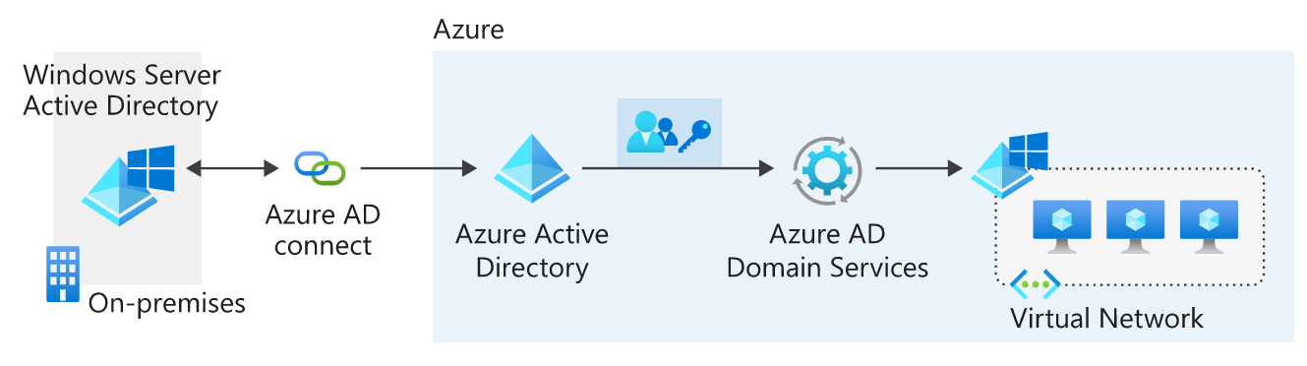
- The organization deploys its apps and servers in a virtual network on Azure.
- Azure AD Connect sync synchronizes identity information between the on-premises Active Directory instance and the organization's tenant in Azure AD.
- The company enables Azure AD DS on their Azure AD tenant.
- The apps and servers in Azure can use features like domain joining and Kerberos authentication.

App management
Your company might provide many apps that internal and external users rely on. Users might want to access these apps from different devices and locations. You can use Azure AD as a cloud-based solution to manage user access for all of these apps.
You can manage different categories of apps in Azure AD:
- Azure AD App Gallery applications. Thousands of SaaS apps are integrated with Azure AD. Find these apps in Azure Marketplace.
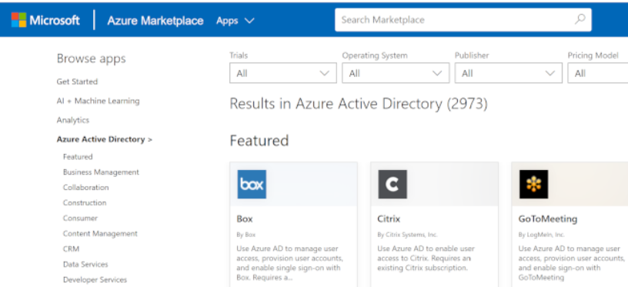
- Custom applications. You can register your company-built apps with Azure AD. You then control and monitor authentication for these apps.
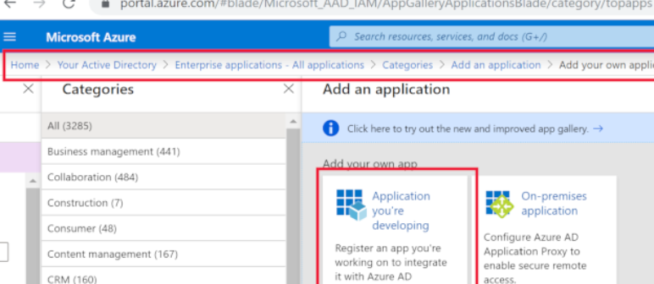
- Non-gallery applications. You can manually add any apps that you don't see in the gallery.
- On-premises applications. You can add on-premises apps by configuring Azure AD Application Proxy. This process creates secure remote access for your on-premises apps. To connect them, download and install the Application Proxy connector on-premises.
Use conditional-access policies to require users to pass additional authentication challenges before they access an app. For example, you can configure a conditional-access policy to require users to complete a multi-factor authentication challenge after their credentials are verified and before they access the app.

Monitor your app access
Azure AD can help monitor your app sign-ins by generating reports that cover sign-in dates, user details, apps the user has used, risk detection, location, and more. Access those reports through the Azure portal or specific APIs for programmatic usage.

Azure AD Identity Protection
Azure AD Identity Protection helps you to automatically detect, investigate, and remediate identity risks for users. Identity Protection also lets you export all the information that was collected about risks. Export the information to third-party tools and solutions so that you can further analyze it.
Identity Protection uses risk policies to automatically detect and respond to threats. You configure a risk policy to set up how Identity Protection should respond to a particular type of risk. Use policies in this way to save time and give you peace of mind.
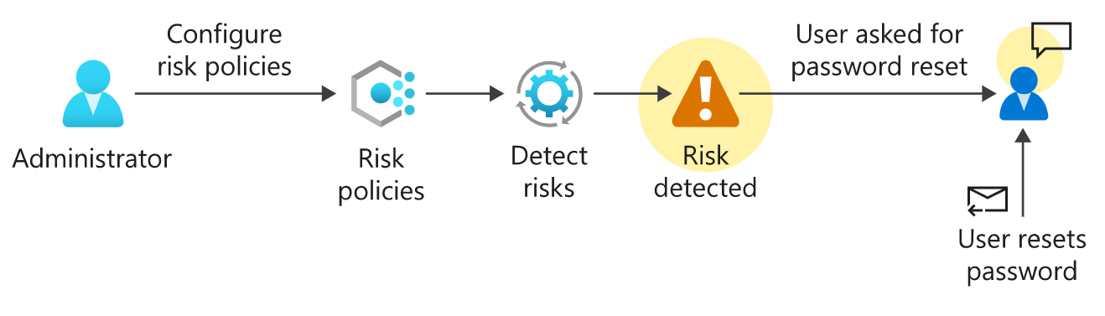

Deploy in phases
A good way to deploy Azure AD is in phases. Your deployment is split into several stages. Each stage addresses a key aspect of Azure AD. A phase includes tasks that you'll need to complete before you go to the next stage. This approach lays a secure foundation for your Azure AD instance.

Stage 1: Build a secure foundation

Assign more than one global administrator , Use regular administrative roles where possible. , Configure Privileged Identity Management (PIM) to track administrators. , Configure self-service password reset. , Create a list of banned passwords. , Warn users to not reuse credentials. , Set passwords to never expire for cloud-based user accounts. , Enforce multi-factor authentication through conditional-access policies. , Configure Azure Active Directory Identity Protection (AADIP).

Stage 2: Add users, manage devices, and configure synchronization

Install and configure Azure AD Connect. , Use password hash synchronization. , Use password writeback. , Use Azure AD Connect Health. , Give users the licenses they need at a group level. , Use Azure AD B2B Collaboration for guest-user access. , Prepare a device-management strategy. , Provide authentication methods that don't require passwords.

Stage 3: Manage your applications

Identify applications. , Use SaaS applications in the Azure AD gallery. , Integrate your on-premises applications by using Application Proxy.

Stage 4: Monitor your administrators, do access reviews, and automate user life cycles
Use PIM to control administrator access. , Complete access reviews for Azure AD directory roles in PIM. , Configure dynamic group membership policies. , Use group-based application assignment. , Configure automated user account provisioning and deactivation.

b) Create Azure users and groups in Azure Active Directory

In Azure Active Directory (Azure AD), all user accounts are granted a set of default permissions. A user's account access consists of the type of user, their role assignments, and their ownership of individual objects.
There are different types of user accounts in Azure AD. Each type has a level of access specific to the scope of work expected to be done under each type of user account. Administrators have the highest level of access, followed by the member user accounts in the Azure AD organization. Guest users have the most restricted level of access.

Permissions and roles
Azure AD uses permissions to help you control the access rights a user or group is granted. This is done through roles. Azure AD has many roles with different permissions attached to them. When a user is assigned a specific role, they inherit permissions from that role. For example, a user assigned to the User Administrator role can create and delete user accounts.

Administrator roles
Administrator roles in Azure AD allow users elevated access to control who is allowed to do what. You assign these roles to a limited group of users to manage identity tasks in an Azure AD organization. You can assign administrator roles that allow a user to create or edit users, assign administrative roles to others, reset user passwords, manage user licenses, and more.

Member users
A member user account is a native member of the Azure AD organization that has a set of default permissions like being able to manage their profile information. When someone new joins your organization, they typically have this type of account created for them.

Guest users
Guest users have restricted Azure AD organization permissions. When you invite someone to collaborate with your organization, you add them to your Azure AD organization as a guest user. Then you can either send an invitation email that contains a redemption link or send a direct link to an app you want to share. Guest users sign in with their own work, school, or social identities. By default, Azure AD member users can invite guest users. This default can be disabled by someone who has the User Administrator role.
az ad user create
New-AzureADUser

$invitations = import-csv c:\bulkinvite\invitations.csv

$messageInfo = New-Object Microsoft.Open.MSGraph.Model.InvitedUserMessageInfo

$messageInfo.customizedMessageBody = "Hello. You are invited to the Contoso organization."

foreach ($email in $invitations)
{New-AzureADMSInvitation `
-InvitedUserEmailAddress $email.InvitedUserEmailAddress `
-InvitedUserDisplayName $email.Name `
-InviteRedirectUrl https://myapps.microsoft.com `
-InvitedUserMessageInfo $messageInfo `
-SendInvitationMessage $true
}
az ad user delete
Remove-AzureADUser
A user account can be restored as long as it's been deleted within the last 30 days. Go to the deleted user list to see the list of all of the deleted users.

Manage app and resource access by using Azure Active Directory groups

Access management in Azure AD
- Azure AD roles: Use Azure AD roles to manage Azure AD-related resources like users, groups, billing, licensing, application registration, and more.
- Role-based access control (RBAC) for Azure resources: Use RBAC roles to manage access to Azure resources like virtual machines, SQL databases, or storage. For example, you could assign an RBAC role to a user to manage and delete SQL databases in a specific resource group or subscription.

Modify the group to use dynamic assignment

c) Authenticate apps to Azure services by using service principals and managed identities for Azure resources

Authentication with service principals in Azure AD

What are Azure service principals?
Think of an Azure service principal as a proxy account, or identity, that represents your app or service. This account is managed by Azure Active Directory (Azure AD). You grant the service principal access to the Azure resources that you need. Use the service principal instead of embedding credentials or creating a dummy account for your app.
Service principals exist at the tenant level in Azure. They're used to grant access to resources in that tenant.
You create your service principal:
- Through the portal
- By using PowerShell
- Through CLI commands
- By using API calls

- Sign in to the Azure portal, and select Azure Active Directory.
- Select App registrations.
- In the upper-left corner, select New registration.
When you finish the steps, the application is registered with Azure AD. It's also associated with a service principal.

Assign application roles
Azure AD applications must be assigned roles so that they can work with other services. Azure uses role-based access control (RBAC) to tightly manage access to Azure resources, and manage how those resources are used. An application's roles determine its permissions and scope.
RBAC permissions are inherited from the level of the scope set. For example, if you assign the reader role to a resource group, read permissions are assigned to all resources within that group.
Use the Azure portal to assign the roles that your app needs to access the key vault:
- In the portal, select your key vault.
- On the left, select Access Control (IAM).
- Select Add role assignment.
- Choose the role that you need.
- On the Members tab, accept the default assign access to option: Azure AD user, group, or service principal.
- Select + Select members.
- Search for and select your application.
- Select Review + assign.
To access Azure resources by using service principals, you need two parameters:
- Directory (tenant) ID: Unique ID that identifies the Azure AD tenant.
- Application (client) ID: Unique ID that identifies your Azure AD application.

When to use service principals
We've now explored the manual processes to create Azure AD applications, associate service principals, and grant access to resources. You use these manual processes in only two scenarios:
- Your application or service is running on-premises.
- The resources or applications that you need to access don't support managed identities.
The most secure and convenient way to handle authentication within Azure is to use managed identities.

What are managed identities in Azure?
You use managed identities to authenticate any Azure service that supports a feature. To use managed identities, you don't need to provide authentication credentials in your code. The managed identity feature solves the credential problem by granting an automatically managed identity. You use this service principal to authenticate to Azure services.

System-assigned managed identity
You enable system-assigned managed identity directly on an Azure service instance, such as a VM. When you enable that identity, Azure creates a service principal through Azure Resource Manager.

User-assigned managed identity
User-assigned managed identity is created as a standalone Azure resource. It's independent of any app. When user-assigned managed identity is provisioned, Azure creates a service principal just as it does for a system-assigned managed identity.
However, a user-assigned managed identity isn't tied to a specific resource, so you can assign it to more than one application. For example, if your web app is deployed on 10 front-end VMs, you create a user-assigned managed identity for the app, and then associate it with all 10 VMs. If you used system-assigned managed identity, you would need 10 identities, and then you would have to manage access for each one.
az vm identity assign \
--name $VMNAME \
--resource-group [Sandbox resource group]
az keyvault secret set \
--vault-name $KVNAME \
--name DBCredentials \
--value "Server=tcp:prodserverSQL.database.windows.net,1433;Database=myDataBase;User ID=mylogin@myserver;Password=examplePassword;Trusted_Connection=False;Encrypt=True;"
az identity list \
--resource-group <resource group>
az functionapp identity assign \
--name <function app name> \
--resource-group <resource group> \
--role <principal id>

d) Configure and manage secrets in Azure Key Vault

az keyvault create \
--resource-group <resource-group> \
--name <your-unique-vault-name>

New-AzKeyVault -Name <your-unique-vault-name> -ResourceGroupName <resource-group>

Key vault uses
With these three elements, an Azure Key Vault helps address the following issues:
- Secrets management. Azure Key Vault can securely store (with HSMs) and tightly control access to tokens, passwords, certificates, API keys, and other secrets.
- Key management. Azure Key Vault is a cloud-based key management solution, making it easier to create and control the encryption keys used to encrypt your data. Azure services such as App Service integrate directly with Azure Key Vault and can decrypt secrets without knowledge of the encryption keys.
- Certificate management. Azure Key Vault is also a service that lets you easily provision, manage, and deploy public and private SSL/TLS certificates for use with Azure and your internal connected resources. It can also request and renew TLS certificates through partnerships with certificate authorities, providing a robust solution for certificate lifecycle management.

Get-AzKeyVaultSecret -VaultName 'VaultamortDiary' -Name 'HiddenLocation'

e) Control authentication for your APIs with Azure API Management

Subscriptions and keys
You can choose to publish your APIs and the information they contain for free, but, usually you want to restrict access to users who have paid or organizations with which you have a working relationship. You can control access to your APIs by using subscriptions. Subscriptions are used to segment the access levels to an API.
The three main subscription scopes are:
SUBSCRIPTIONS AND KEYS
Scope | Details
All APIs | Applies to every API accessible from the gateway.
Single API | Applies to a single imported API and all of its endpoints.
Product | A product is a collection of one or more APIs that you configure in APIM. You can assign APIs to more than one product. Products can have different access rules, usage quotas, and terms of use. So, if you want your partners and suppliers to have different access rights to your WeatherData API, assign the API to a product, and then use the Azure portal to associate APIs with a product.
Applications that call a protected API must include a subscription key in every request.
You can regenerate these subscription keys at any time; for example, if you suspect that a key has been shared with unauthorized users, you can create a new one.
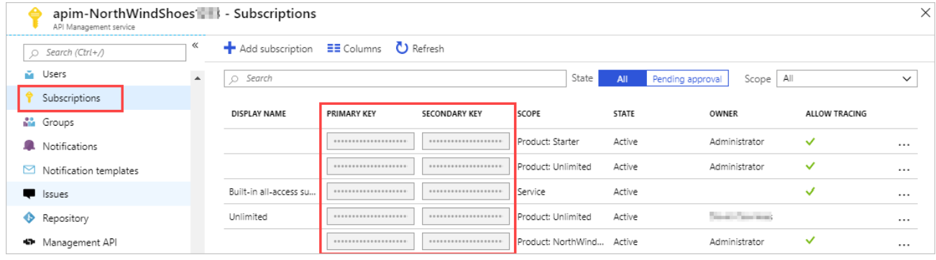

Call an API with the subscription key
Applications must include a valid key in all HTTP requests that make calls to API endpoints that are protected by a subscription. Keys can be passed in the request header or as a query string parameter in the URL.
The default subscription key header name is Ocp-Apim-Subscription-Key, and the default query string name is subscription-key.

Use client certificates to secure access to an API
Certificates can be used to provide TLS mutual authentication between the client and the API gateway. You can configure the API Management gateway to allow only requests with certificates containing a specific thumbprint. The authorization at the gateway level is handled through inbound policies.

Edit inbound policy to only allow requests with a valid certificate

f) Protect against security threats on Azure

Protect against security threats by using Azure Security Center

Azure Security Center is a monitoring service that provides visibility of your security posture across all of your services, both on Azure and on-premises. The term security posture refers to cybersecurity policies and controls, as well as how well you can predict, prevent, and respond to security threats.
Security Center can:
- Monitor security settings across on-premises and cloud workloads.
- Automatically apply required security settings to new resources as they come online.
- Provide security recommendations that are based on your current configurations, resources, and networks.
- Continuously monitor your resources and perform automatic security assessments to identify potential vulnerabilities before those vulnerabilities can be exploited.
- Use machine learning to detect and block malware from being installed on your virtual machines (VMs) and other resources. You can also use adaptive application controls to define rules that list allowed applications to ensure that only applications you allow can run.
- Detect and analyze potential inbound attacks and investigate threats and any post-breach activity that might have occurred.
- Provide just-in-time access control for network ports. Doing so reduces your attack surface by ensuring that the network only allows traffic that you require at the time that you need it to.

Understand your security posture
Tailwind Traders can use Security Center to get a detailed analysis of different components in its environment. Because the company's resources are analyzed against the security controls of any governance policies it has assigned, it can view its overall regulatory compliance from a security perspective all from one place.
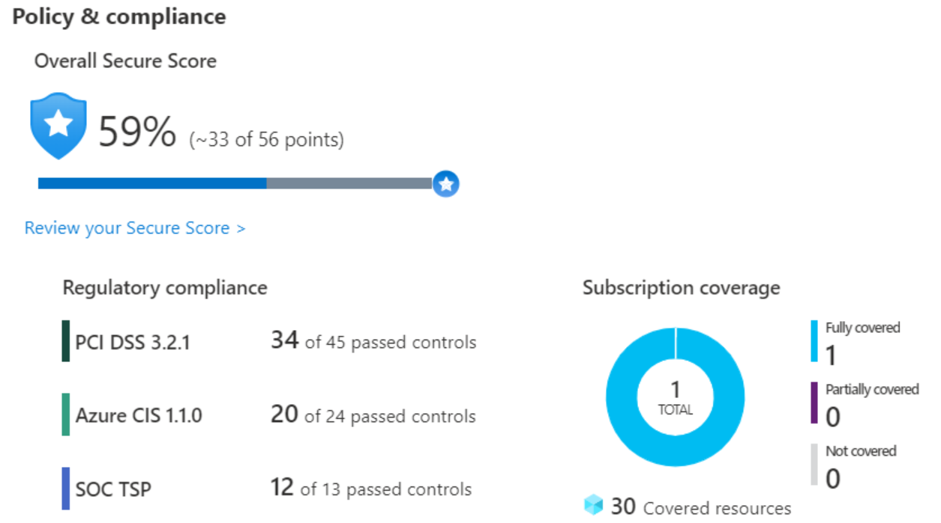
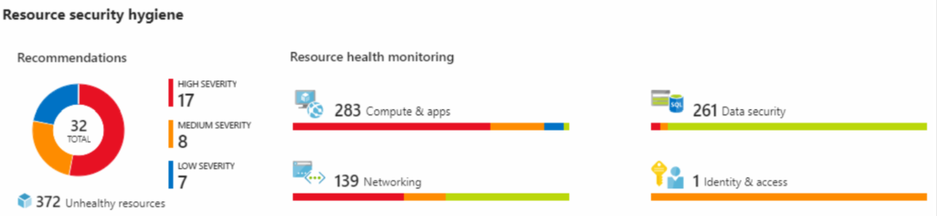

Protect against threats
Security Center includes advanced cloud defense capabilities for VMs, network security, and file integrity. Let's look at how some of these capabilities apply to Tailwind Traders.
- Just-in-time VM access Tailwind Traders will configure just-in-time access to VMs. This access blocks traffic by default to specific network ports of VMs, but allows traffic for a specified time when an admin requests and approves it.
- Adaptive application controls Tailwind Traders can control which applications are allowed to run on its VMs. In the background, Security Center uses machine learning to look at the processes running on a VM. It creates exception rules for each resource group that holds the VMs and provides recommendations. This process provides alerts that inform the company about unauthorized applications that are running on its VMs.
- Adaptive network hardening Security Center can monitor the internet traffic patterns of the VMs, and compare those patterns with the company's current network security group (NSG) settings. From there, Security Center can make recommendations about whether the NSGs should be locked down further and provide remediation steps.
- File integrity monitoring Tailwind Traders can also configure the monitoring of changes to important files on both Windows and Linux, registry settings, applications, and other aspects that might indicate a security attack.

Azure Sentinel capabilities
Azure Sentinel enables you to:
- Collect cloud data at scale Collect data across all users, devices, applications, and infrastructure, both on-premises and from multiple clouds.
- Detect previously undetected threats Minimize false positives by using Microsoft's comprehensive analytics and threat intelligence.
- Investigate threats with artificial intelligence Examine suspicious activities at scale, tapping into years of cybersecurity experience from Microsoft.
- Respond to incidents rapidly Use built-in orchestration and automation of common tasks.

Azure Sentinel supports a number of data sources, which it can analyze for security events. These connections are handled by built-in connectors or industry-standard log formats and APIs.
Connect Microsoft solutions
Connect other services and solutions
Connect industry-standard data sources

Tailwind Traders needs to be notified when something suspicious occurs. It decides to use both built-in analytics and custom rules to detect threats.

Here's an example that shows what an investigation graph looks like in Azure Sentinel.

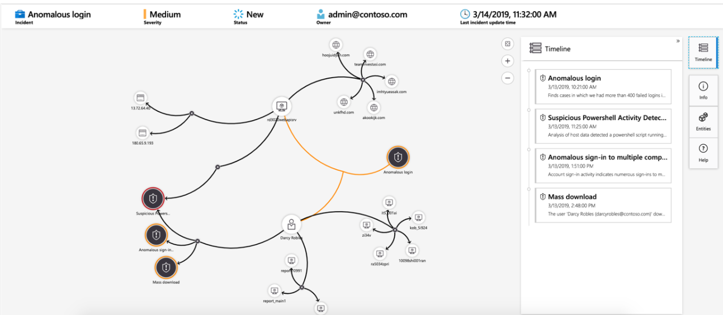

On Azure, virtual machines (VMs) run on shared hardware that Microsoft manages. Although the underlying hardware is shared, your VM workloads are isolated from workloads that other Azure customers run.
Some organizations must follow regulatory compliance that requires them to be the only customer using the physical machine that hosts their virtual machines. Azure Dedicated Host provides dedicated physical servers to host your Azure VMs for Windows and Linux.

g) Monitor and report on security events in Azure AD

Use sign-in, audit, and provisioning logs to detect suspicious activity

Activity logs cover all of a user's behaviors and interactions with your network and their assets. You want to pay attention to two types of log files in particular:
- Sign-in logs: Hold details about all user activity and the applications that requested them.
- Audit logs: Show what a user or group did while signed in to your network.
Security logs represent a list of the exceptions found in the activity logs. Worthy of note are two key log files:
- Risky sign-ins: Hold data about user accounts where the sign-in behavior is inconsistent with previous sign-in attempts.
- Users flagged for risk: Show you all users who have been assigned a risky user flag.

Prerequisites
Because of the nature of the log data that's captured by the sign-in logs, access is reserved and limited. To use the sign-in log files, you need:
- An Azure AD Premium or better subscription.
- At least one user who has a Global Administrator, Report Reader, Security Reader, or Security Administrator role or permissions.

Integrate activity logs with Azure Monitor logs

Send user logs to the Log Analytics workspace

What are the two types of queries you can write in Azure Monitor
Table-based and search-based

Set up reports and dashboards to visualize the information

Sign-ins Events and Azure AD Account Provisioning Events are the two prebuilt views you can download and install in your Log Analytics workspace.

h) Maintain a secure repository by using GitHub best practices

How to maintain a secure GitHub repository

Keep sensitive files out of your repository with .gitignore

Branch protection rules
You can create a branch protection rule to enforce certain workflows for one or more branches, such as requiring an approving review or passing status checks for all pull requests merged into the protected branch.
The workflows that protect the branch can be leveraged to:
- Run a build to verify the code changes can be build
- Run a linter to check for typos and conformation to the internal coding conventions
- Run automated tests to check for any behavior changes of the code
- Etc.

Detect and fix outdated dependencies with security vulnerabilities

Automated dependency updates with Dependabot
Another advantage to code scanning is its ability to use CodeQL. CodeQL lets you query code as data which enables you to create custom queries, or use queries maintained by the open-source community. Code scanning gives you freedom to customize and maintain how the code within your repository is being scanned.

i)Build a cloud governance strategy on Azure

When running in the cloud, a good governance strategy helps you maintain control over the applications and resources that you manage in the cloud. Maintaining control over your environment ensures that you stay compliant with:
- Industry standards, like PCI DSS.
- Corporate or organizational standards, such as ensuring that network data is encrypted.
Governance is most beneficial when you have:
- Multiple engineering teams working in Azure.
- Multiple subscriptions to manage.
- Regulatory requirements that must be enforced.
- Standards that must be followed for all cloud resources.

How is role-based access control applied to resources?
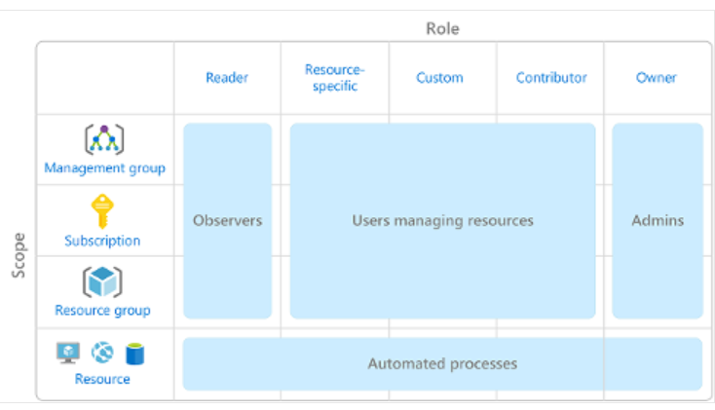
Scopes include:
- A management group (a collection of multiple subscriptions).
- A single subscription.
- A resource group.
- A single resource.
When you grant access at a parent scope, those permissions are inherited by all child scopes

Who does Azure RBAC apply to?
You can apply Azure RBAC to an individual person or to a group. You can also apply Azure RBAC to other special identity types, such as service principals and managed identities. These identity types are used by applications and services to automate access to Azure resources.
Tailwind Traders has the following teams with an interest in some part of their overall IT environment:
- IT Administrators This team has ultimate ownership of technology assets, both on-premises and in the cloud. The team requires full control of all resources.
- Backup and Disaster Recovery This team is responsible for managing the health of regular backups and invoking any data or system recoveries.
- Cost and Billing People in this team track and report on technology-related spend. They also manage the organization's internal budgets.
- Security Operations This team monitors and responds to any technology-related security incidents. The team requires ongoing access to log files and security alerts.
The following screenshot shows an example of the Access control (IAM) pane for a resource group. In this example, Alain Charon has been assigned the Backup Operator role for this resource group.

Prevent accidental changes by using resource locks
To view, add, or delete locks in the Azure portal, go to the Settings section of any resource's Settings pane in the Azure portal.
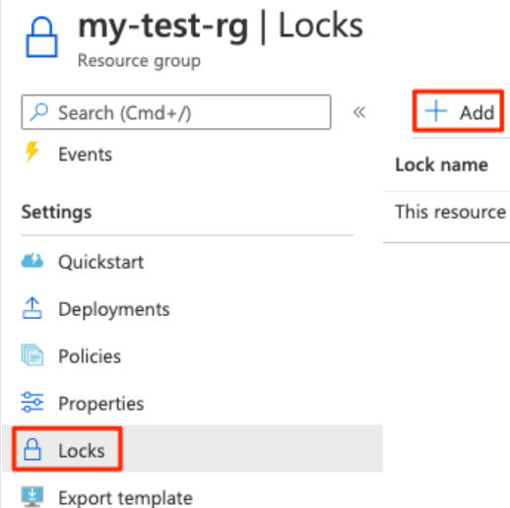
You can apply locks to a subscription, a resource group, or an individual resource. You can set the lock level to CanNotDelete or ReadOnly.
- CanNotDelete means authorized people can still read and modify a resource, but they can't delete the resource without first removing the lock.
- ReadOnly means authorized people can read a resource, but they can't delete or change the resource. Applying this lock is like restricting all authorized users to the permissions granted by the Reader role in Azure RBAC.

Organize your Azure resources by using tags

This metadata is useful for
Resource management , Cost management and optimization , Operations management , Security , Governance and regulatory compliance , Workload optimization and automation
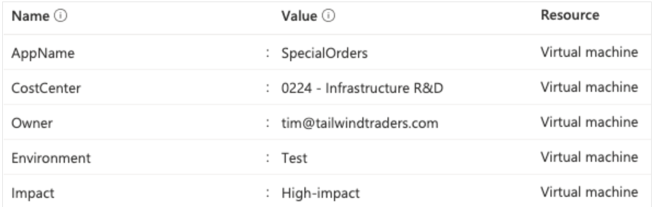

How does Azure Policy define policies?
Azure Policy enables you to define both individual policies and groups of related policies, known as initiatives. Azure Policy evaluates your resources and highlights resources that aren't compliant with the policies you've created. Azure Policy can also prevent noncompliant resources from being created.

Azure Policy in action
Implementing a policy in Azure Policy involves three tasks:
- Create a policy definition.
- Assign the definition to resources.
- Review the evaluation results.
Allowed virtual machine SKUs This policy enables you to specify a set of VM SKUs that your organization can deploy.
Allowed locations This policy enables you to restrict the locations that your organization can specify when it deploys resources. Its effect is used to enforce your geographic compliance requirements.
MFA should be enabled on accounts with write permissions on your subscription This policy requires that multifactor authentication (MFA) be enabled for all subscription accounts with write privileges to prevent a breach of accounts or resources.
CORS should not allow every resource to access your web applications Cross-origin resource sharing (CORS) is an HTTP feature that enables a web application running under one domain to access resources in another domain. For security reasons, modern web browsers restrict cross-site scripting by default. This policy allows only required domains to interact with your web app.
System updates should be installed on your machines This policy enables Azure Security Center to recommend missing security system updates on your servers.

Task 2. Assign the definition to resources

Task 3. Review the evaluation results

Restrict deployments to a specific location by using Azure Policy

Govern multiple subscriptions by using Azure Blueprints
Instead of having to configure features like Azure Policy for each new subscription, with Azure Blueprints you can define a repeatable set of governance tools and standard Azure resources that your organization requires. In this way, development teams can rapidly build and deploy new environments with the knowledge that they're building within organizational compliance

Accelerate your cloud adoption journey by using the Cloud Adoption Framework for Azure

Cloud Adoption Framework consists of tools, documentation, and proven practices. The Cloud Adoption Framework includes these stages:
- Define your strategy.
- Make a plan.
- Ready your organization.
- Adopt the cloud.
- Govern and manage your cloud environments.
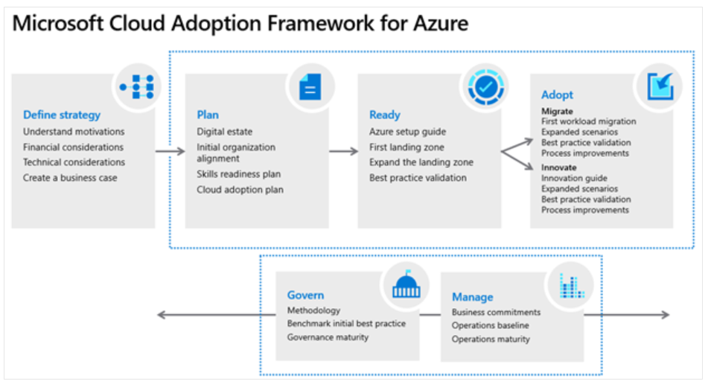

j) Improve your reliability with modern operations practices: Learning from failure

What is a post-incident review

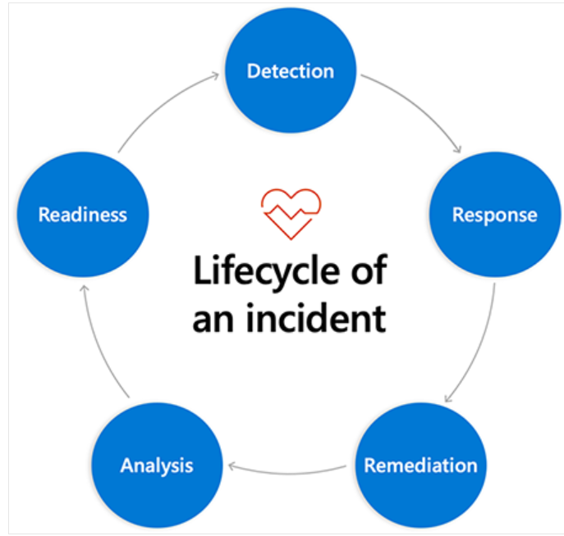

The post-incident review process

Gather the data

Azure tools to help gather the data

Azure DevOps for holding metadata about the incident

Microsoft Graph API for extracting the conversation

Targeted dashboards for context display

Audit Logs and Log Analytics for change exploration

Common traps to avoid

Attribution to “human error”

Counterfactual reasoning

Normative language

Mechanistic reasoning

Helpful practices for learning from failure

Run a facilitated post-incident review

Ask better questions

Ask how things went right

Keep review and planning meetings separate

k) Improve your reliability with modern operations practices: Incident response

Incident response also has a foundation itself. A good incident response plan is supported by three pillars:
- Rosters
- Roles
- Rotations

